**Day 11 Task: Advance Git & GitHub for DevOps Engineers: Part-2**

#owner= vishal saxena

**Task-01**

* Create a new branch and make some changes to it.
* Use git stash to save the changes without committing them.
* Switch to a different branch, make some changes and commit them.
* Use git stash pop to bring the changes back and apply them on top of the new commits.

Answer : -

**Please check the below images for the reference of the answers of the above of the questions.**

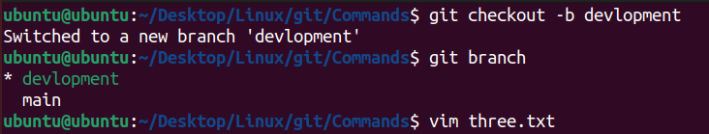

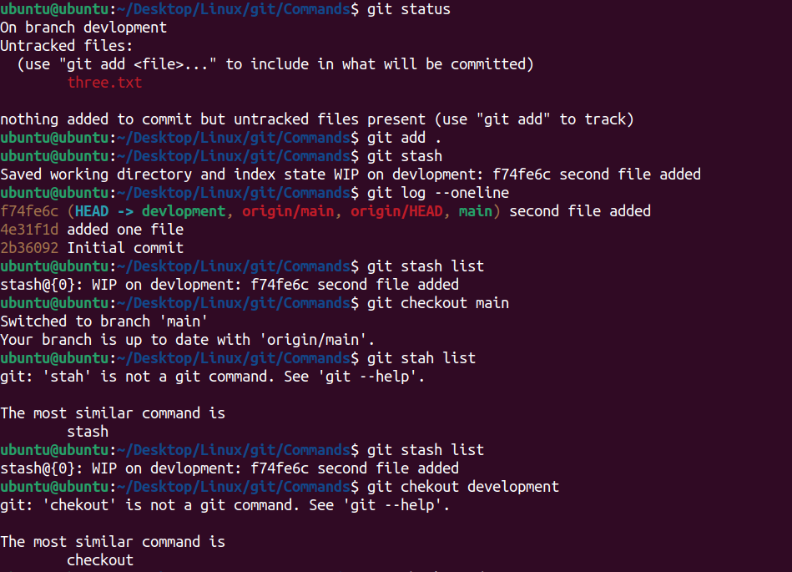

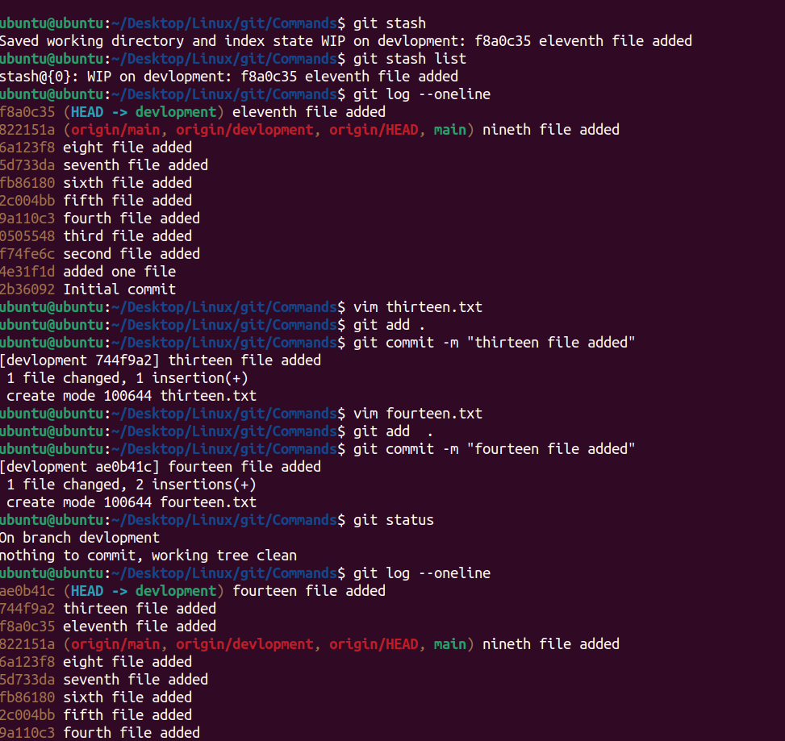

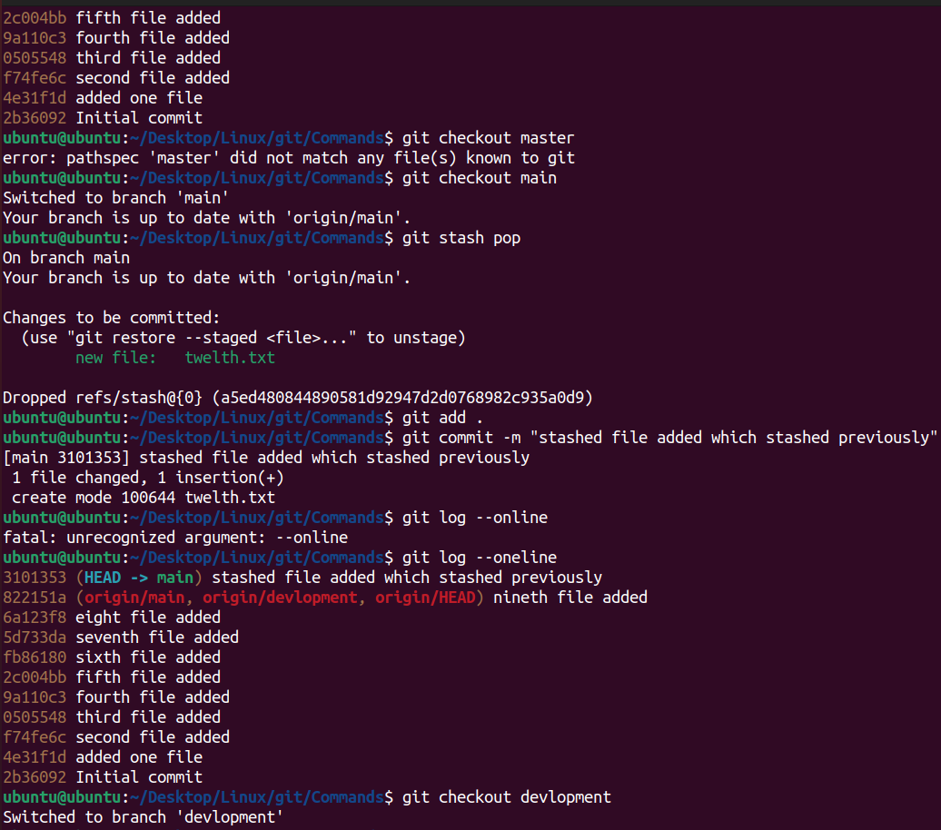

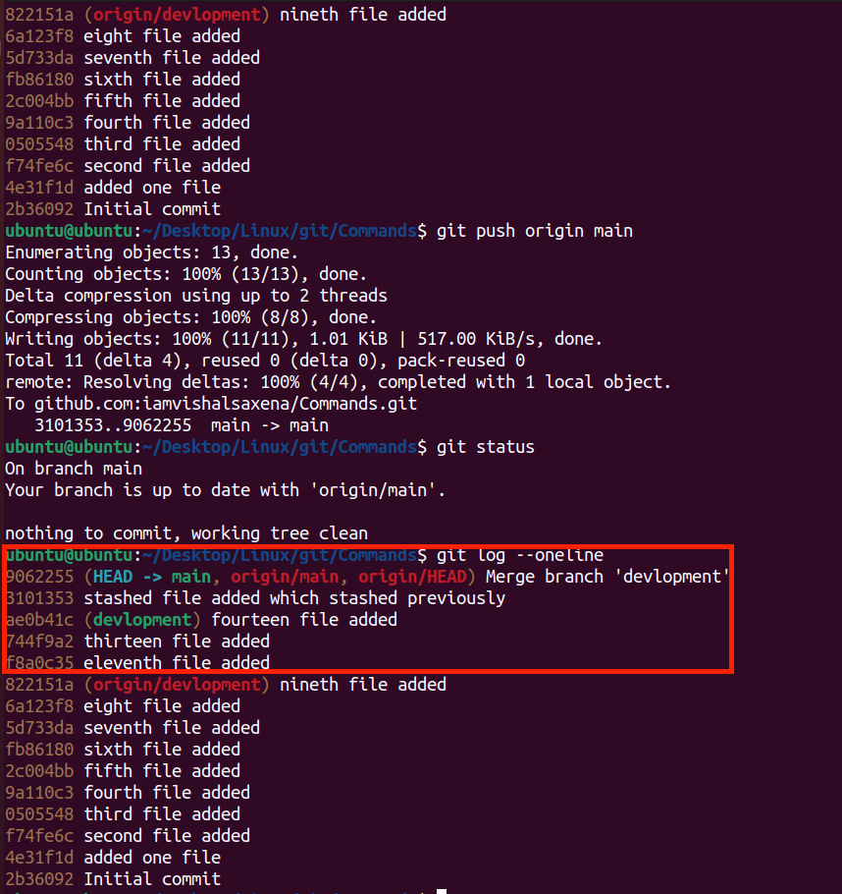

**If you can see the above image you can observe the highlighted section where the previously stashed commit is on the top of recent commits.**

**Task-02**

* In version01.txt of development branch add below lines after “This is the bug fix in development branch” that you added in Day10 and reverted to this commit.
* Line2>> After bug fixing, this is the new feature with minor alteration”

Commit this with message “ Added feature2.1 in development branch”

* Line3>> This is the advancement of previous feature

Commit this with message “ Added feature2.2 in development branch”

* Line4>> Feature 2 is completed and ready for release

Commit this with message “ Feature2 completed”

* All these commits messages should be reflected in Production branch too which will come out from Master branch (Hint: try rebase).

**Answers :**

**Please check the below images for the reference of the answers of the above of the questions.**

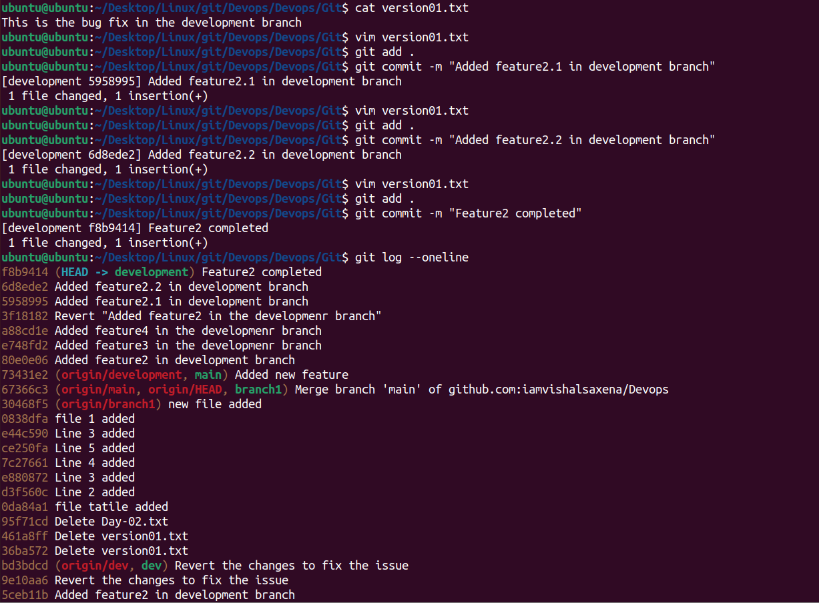

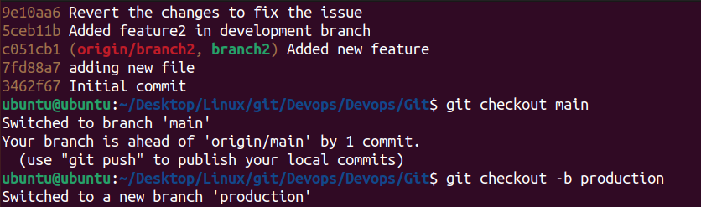

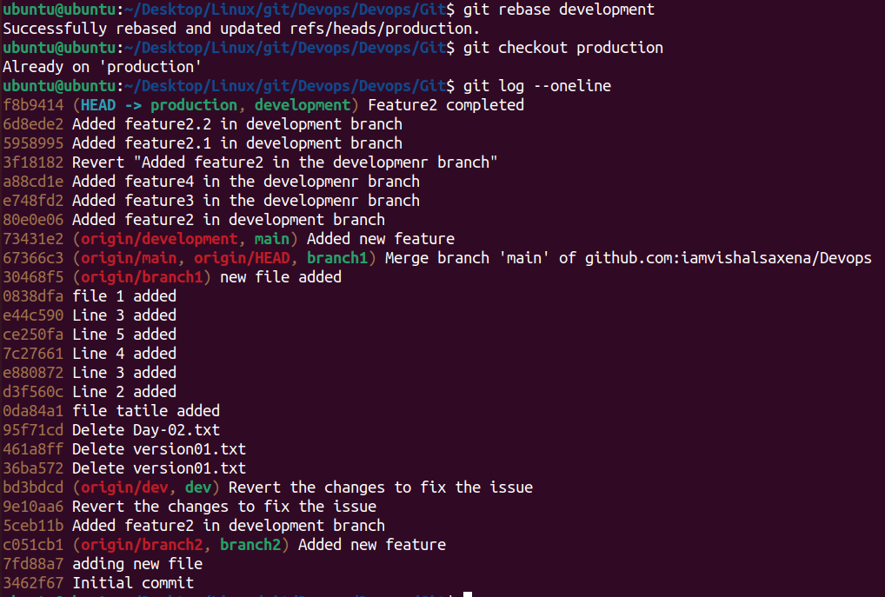

**Task-03**

* In Production branch Cherry pick Commit “Added feature2.2 in development branch” and added below lines in it:
* Line to be added after Line3>> This is the advancement of previous feature
* Line4>>Added few more changes to make it more optimized.

Commit: Optimized the feature  
**Please check the below images for the reference of the answers of the above of the questions.**

